5.4 Reed-Muller-Codes
Reed-Muller-Code RM (r, m) r-ter Ordnung der Länge 2 ^{m} ist rekursiv (| x | x + y | – Konstruktion):

(1a) RM (0, m) = { (0...0), (1...1) }
(1b) RM (m, m) = (GF (2) ) ^{2 hoch m}

(2) RM (r, m) = { (x, x + y) | x aus RM (r, m – 1); y aus RM (r – 1, m – 1) }
für 0 < r < m – 1.

Beachte: = +

Bsp RM (0, 0) = {0, 1} RM (0, 1) = {00, 11} RM (0, 2) = {000, 111} (1a)

RM (1, 1) = {00, 11, 01, 10} RM (2, 2) = {00, 11, 01, 10} ² (1b)

Generatormatrizen von RM (r, m) sind (mit 0 < r < m):

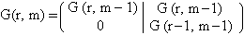

r = 0: G (0, m) = (1...1)

 | r = m: | 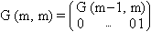

Bsp | (i) | G (0, 1) = (1 1) | 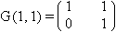

(ii) m = 2, also Länge 4 mit r = 1, 2:

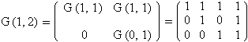

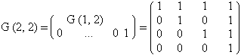

Eigenschaften von RM (r, m) (1) Länge n = 2 ^{m}
(2) Minimalabstand d = 2 ^{m-r}
(3) Dimension k = _{i=0,...,r}
(4) RM (r – 1, m) RM (r, m) für r > 0
(5) Dualer Code ist RM (m – 1 – r, m) mit r < m

Minimalabstand und Dimension k = Dim RM (r, m); d = 2 ^{m-r} Minimalabstand

 | m | r | 0 | 1 | 2 | 3 | 4 | 5
 | 0 |  | d = 1  k = 1
 | 1 |  | d = 2  k = 1 | d = 1  k = 2
 | 2 |  | d = 4  k = 1 | d = 2  k = 3 | d = 1  k = 4
 | 3 |  | d = 8  k = 1 | d = 4  k = 4 | d = 2  k = 7 | d = 1  k = 8
 | 4 |  | d = 16  k = 1 | d = 8  k = 5 | d = 4  k = 11 | d = 2  k = 15 | d = 1  k = 16
 | 5 |  | d = 32  k = 1 | d = 16  k = 6 | d = 8  k = 16 | d = 4  k = 26 | d = 2  k = 31 | d = 1  k = 32

